* From H to D:
  + Take the farthest number to the right and multiply it like so:
    - Ex: 0xDF23
    - (3*16^0)+(2*16^1)+(16*16^2)+(13*16^3)
    - to get 57123
* From D to H
  + Divde my 16 and take the remainders and reverse the order
    - Ex: 23834
    - 23834/16 = 1484 R 10 (A)
    - 1484/16 = 93 R 1 (1)
    - 93/16 = 5 R 13 (D)
    - 5/16 = 0 R 5 (5)
    - now read bottom to top for the remainders
    - to get 0x5D1A

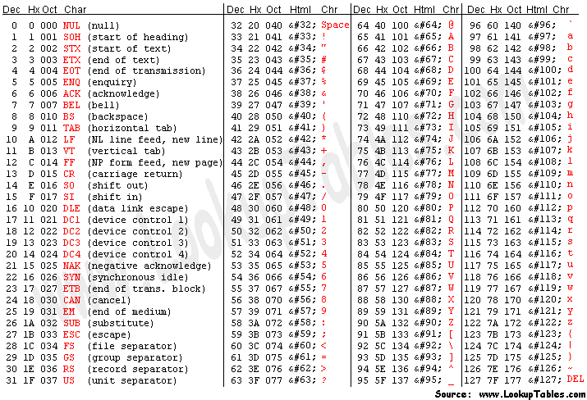

* Transposition ciphers:
  + They change the order of the characters, but no the characters themselves
  + Columnar transposition:
    - Takes a base word as the top of the column and one you figure out the base word all the other letters should line up
    - You generally do not include spaces
  + Scytale cipher:

| | | | | | |

| H | E | L | P | M | |

__| E | I | A | M | U |__|

| | N | D | E | R | A |

| | T | T | A | C | K |

| | | | | | |

* Monoalphabetic ciphers keep ordering od the characters the same, but implement a fixed substitution of plaintext characters to cipher text characters:
  + Caesar Cipher:
    - Each letter of plaintext is replaced by a letter a fixed number of positions down the alphabet
    - Often implemented with a wheel
* Polyalphabetic ciphers are substitution ciphers that use multiple alphabets to encrypt messages
  + Vigenere Cipher:
    - Use multiple Caesar ciphers on plaintext
    - 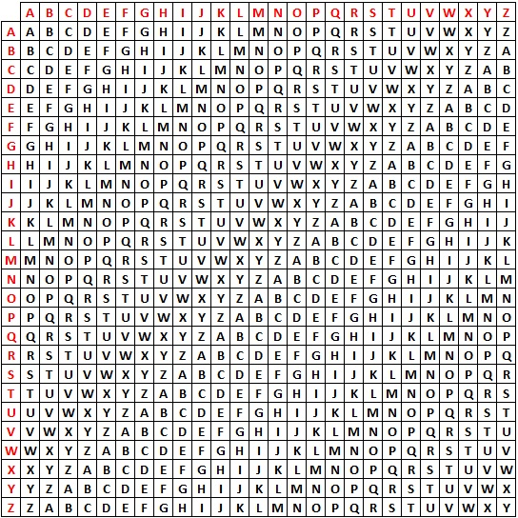
* Public Key Encryption:
  + Key distribution problem simplified, there are not shared secret keys unlike the enigma
  + Relies upon a difficult math problem to protect you encrypted data
  + There are two parts to public key encryption, there is the public key that is published by the recipient and there is the private key that is kept secret by the recipient
  + Sender encrypts data using the public key
  + Recipient decrypts data using private key
* Dominating Set encryption: